THIS DOCUMENT IS A SAMPLE ONLY. PLEASE DO NOT FILL AND SUBMIT THIS FORM.
ELECTRONIC FINGERPRINT SUBMISSION RELEASE OF INFORMATION

Applicant Section

I authorize the North Carolina Department of Public Safety through the State Bureau of Investigation, Criminal Information and Identification Section to perform a fingerprint search of the State’s criminal history records and, if applicable, a fingerprint search of the Federal Bureau of Investigation’s files for a national criminal history records check in connection with my application for employment or application for license with DHHS DIVISION OF MEDICAL ASSISTANCE pursuant to 42 CFR 455.434.

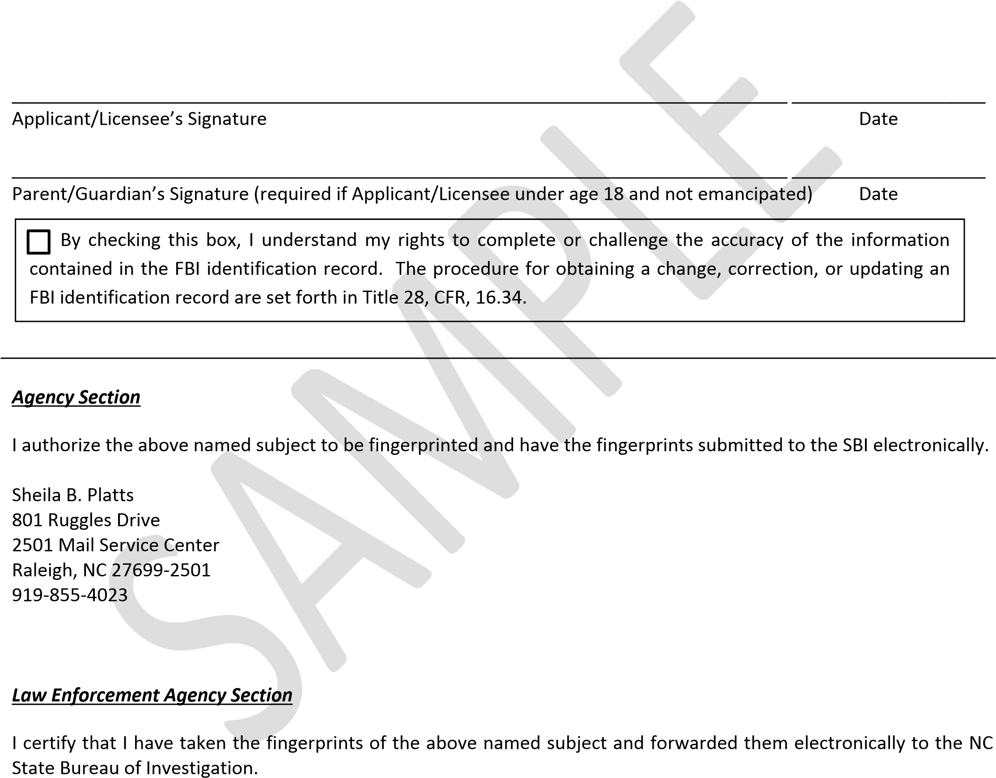
I understand that the North Carolina State Bureau of Investigation, Criminal Information and Identification Section, the Federal Bureau of Investigation, and its officials and employees shall not be held legally accountable in any way for providing this information to the agency named below, and I hereby release said agency and persons from any and all liability which may be incurred as a result of furnishing such information. I further understand that the agency cannot provide a copy of the results of this criminal history records check to me.

____________________________________________________________________________ ___________________
Signature of Official Taking Fingerprints Date

________________________________________________________________________________________________
Agency Seal/Certification (If no official seal, please print your agency address)

APPLICANT INFORMATION

Your Case No. (OCA): XXXXXXXXXXXXXXXXXXXX

Last Name: XXXXXXXXXXXXXXXXXXXXXXXXXXXXXXXXXXX
First Name: XXXXXXXXXXXXXXXXXXXXXXXXX
Middle Name: XXXXXXXXXXXXXXXXXXXXXXXXX

Sex: ____________ (MALE/FEMALE)

*Social Security Number: ___________________

Date of Birth: ____/____/YYYY Place of Birth ________________________

Residence: ________________________ Maiden Name: ______________________

Aliases: ___________________________ __________________________________

__________________________________

Race: _____________________________ Height: __________________________
(write the appropriate letter in the space provided)
W – White, B – Black, I – American Indian, A – Asian or Pacific Islander, U - Unknown

Eye Color: _________________________ Weight: ___________________________
(write the appropriate letters in the space provided)
BLK – Black, GRY – Gray, MAR – Maroon, BLU – Blue, BRO – Brown, GRN – Green, HAZ – Hazel, PNK – Pink, XXX – Unknown

Hair Color: _________________________
(write the appropriate letters in the space provided)

BAL – Bald, BLK – Black, BLN – Blonde or Strawberry, BRO – Brown, GRY – Gray or partially, RED – Red or Auburn, SDY - Sandy







*The social security number will be utilized to assist with accurate identification/exclusion of possible criminal history records.

Employer and Address:
DHHS-DIVISION OF MEDICAL ASSISTANCE
801 RUGGLES DR
RALEIGH, NC, 27699
Reason Fingerprinted:
DHHS DIVISION OF MEDICAL ASSISTANCE - STATE AND FEDERAL - 42 CFR 455.434
Type of Transaction: NFUF NC FP Card Type: OTH

