Java Quick Reference
The purpose of this document is to provide a visual reference of Java prompts that a user might encounter with the various Skillsoft product offerings, what they mean, and how to respond to them. In some cases, the prompts are normal and will always be presented, while in others there may be a configuration change or future fix that Skillsoft is working to deliver to eliminate the prompt.
What do you see? | What is it? | What should you do?
When Java tries to load an applet while using Chrome:  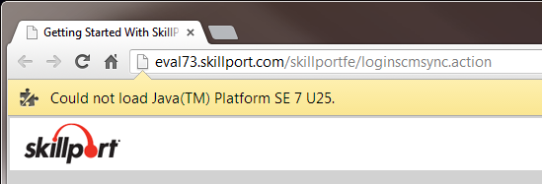 | This prompt indicates that Java is not installed or is not enabled for use in the browser. The message text may differ slightly depending on the current release of Java. | Java either needs to be installed or enabled for use in the browser.
When Java tries to load an applet while using Safari on a Mac:    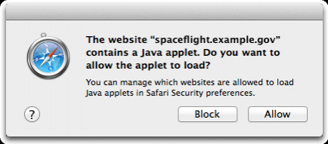 | This prompt indicates that Java is being blocked by the browser.  This prompt indicates that a Java applet is attempting to execute. | Java must be enabled to run in the browser, and the user must click Allow to allow the applet to run.
When Java tries to load an applet using any browser:  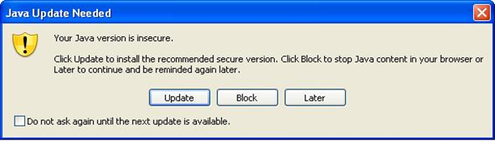  OR  Or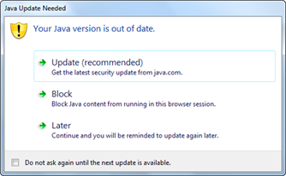  Or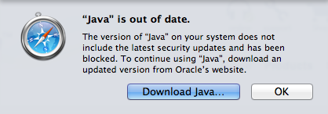 | These prompts indicates that the version of the JRE that the user has installed is outdated, a newer version is available.  This message is from Safari on a Mac, and indicates that the installed JRE needs to be updated. | The user must click either Update to allow the JRE to be updated to the new version, or Later to defer the JRE update and allow the applet to launch with the current installed JRE. They may optionally check the box to prevent further prompting until the next JRE update is detected.  NOTE: If you click Later, you might have problems playing SCORM content using the SCORM RTE, or launching unsigned applets. This is due to security restrictions imposed on older JREs when they no longer meet the minimum security baseline.  The user must install the updated version of Java.
When Java tries to load an applet while using Chrome: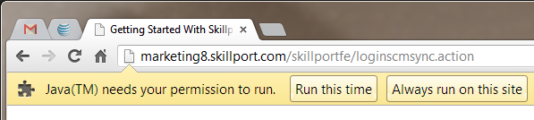 | This is a prompt that Google Chrome presents whenever a Java applet attempts to load. | The user must click either Run this time or Always run on this site. If you click Run this time, you will be prompted each time Java attempts to run when you visit this site. If you click Always run on this site, then Chrome will not prompt you again when Java applets attempt to run on this site.
When Java tries to load an applet while using Internet Explorer:  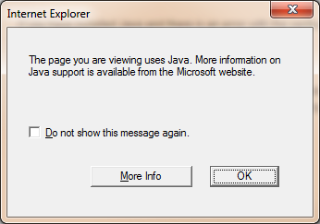 | This prompt indicates that Java is not installed or is not enabled for use in the browser. | Java either needs to be installed or enabled for use in the browser.
When trying to login to Skillport using Firefox:  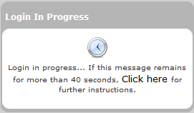  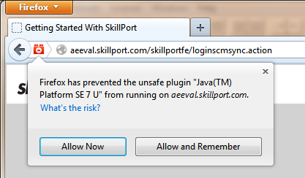 | If Java is not installed or is disabled for use in the browser, Firefox will not give any indication when a Java applet is encountered. The browser will simply stop on the page where the Java applet was trying to launch.  As of Firefox v24.0, Java is blocked by default. The red plugin icon in the browser address bar indicates that a plugin (e.g., Java) was blocked on this site. | Java either needs to be installed or enabled for use in the browser.  To allow Java to run in Firefox v24.0 or newer, click the red plugin icon in the address bar. The user can click Allow Now to allow the applet to run once, or Allow and Remember to allow this applet to run in the future without prompting.
When Java tries to load an unsigned applet:  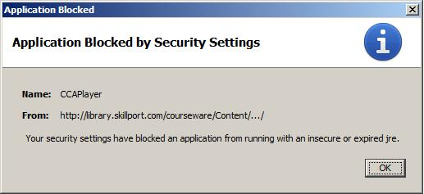 | This prompt is displayed by the JRE (starting with 1.7.0_21) when an unsigned Java applet attempts to load and the user is not running a JRE that meets the current security baseline.  Oracle uses the concept of security baselines to insure that users are running a current and secure version of the JRE. Certain functions in older JREs are blocked when a new security baseline is established. | The user must either upgrade their JRE to the current security baseline, or switch to a signed version of the applet that is trying to run.  If this prompt is displayed when launching a Skillsoft course, you may be able to switch to the signed version of the Player applet to replace this message with the signed applet warning.
When Java tries to load an unsigned applet:  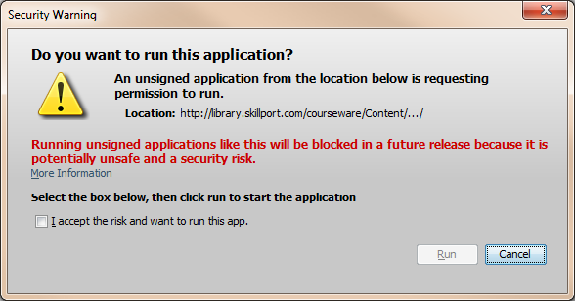 | This is the JRE prompt warning that unsigned applets will no longer be supported in a future release of the JRE. This message started appearing with JRE 1.7.0_40.  Oracle has indicated that unsigned applets will no longer be supported as of JRE 1.7.0_51, which is scheduled for January 2014 release. | The user must check the box to accept the risk, and click Run. If you see this prompt when launching a Skillsoft course, you may be able to switch to the signed version of the Player applet to replace this message with the signed applet warning.
When launching any signed Java applet with JRE 1.7.0_45:  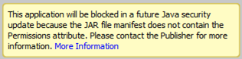 | This warning text appears on the JRE prompt for a signed applet with JRE 1.7.0_45. New requirements around Java applet signing are causing the additional yellow warning text to appear for our signed applets. This yellow text will appear for any signed applet, not just at Skillport login.  Software engineering is working on a fix to address the new requirements to eliminate the additional warning text. | The user must click Run to allow the applet to execute.  You can also check the box Do not show this again for apps from this Publisher and location above. This will suppress prompts for this applet on future launches.
When logging in to Skillport:  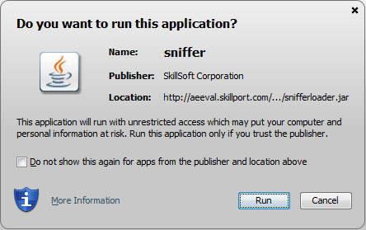 | This is the JRE prompt for the signed version of the sniffer applet. The sniffer applet is used to detect whether the SCM is installed on a user’s computer. The applet writes a session cookie indicating whether it detected the SCM or not.  Note: There has been some concern raised due to the name of the Sniffer applet. The renamed applet will be deployed in the following patches:  Skillport 7.0 patch 19 (complete)  Skillport 7.2 patch 27 (in progress)  Skillport 7.3 patch 21 (complete)  Skillport 8.0 patch 12 (planned) | The user must click Run to allow the applet to execute. The sniffer applet is necessary if the customer uses Download. If the customer does not use Download at all, the sniffer applet may be disabled.  You can also check the box Do not show this again for apps from this Publisher and location above. This will suppress prompts for this applet on future launches.
When logging in to Skillport:  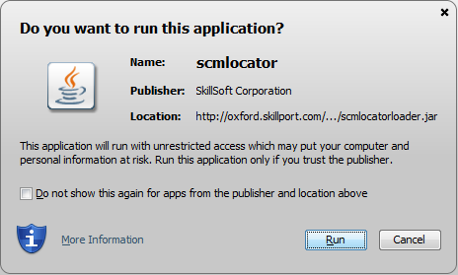 | This is the JRE prompt for the renamed sniffer applet. The scmlocator applet is used to detect whether the SCM is installed on a user’s computer. The applet writes a session cookie indicating whether it detected the SCM or not. | The user must click Run to allow the applet to execute. This applet is necessary if the customer uses Download. If the customer does not use Download at all, the applet may be disabled.  You can also check the box Do not show this again for apps from this Publisher and location above. This will suppress prompts for this applet on future launches.
When logging in to Skillport or downloading a course: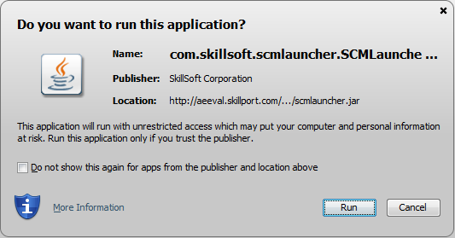 | This is the JRE prompt for the signed applet to launch the SCM. This applet will launch whenever a user logs into Skillport or attempts to download a course if they have the “registry-free” (regfree) version of the SCM installed. | The user must click Run to allow the applet to execute.  You can also check the box Do not show this again for apps from this Publisher and location above. This will suppress prompts for this applet on future launches.
When trying to download a course: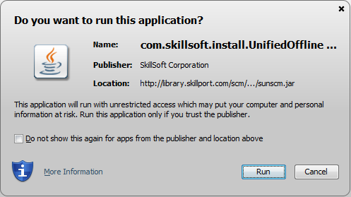 | This is the JRE prompt for the signed applet to install the SCM. When a user chooses to download a course and they do not yet have the SCM installed, they will be prompted to install it. This is the applet that performs the SCM installation to the user’s computer.  The user should only need to do this once on any given machine to install the SCM. | The user must click Run to allow the applet to execute.
When launching a CCA course using the unsigned Player applet:  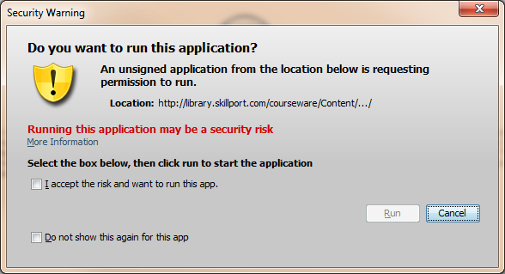 | This is the JRE prompt for the unsigned applet version of the Skillsoft Course Player for CCA courses when using JRE version 1.7.0_25 or higher.  Oracle has indicated that unsigned applets will no longer be supported as of JRE 1.7.0_51, which is scheduled for January 2014 release. | The user must check the box to accept the risk, and click Run. You can also check the box to not show the prompt again for this applet.  If you see this prompt when launching a Skillsoft course, you may be able to switch to the signed version of the Player applet to replace this message with the signed applet warning.
When launching a CCA course using the signed Player applet:  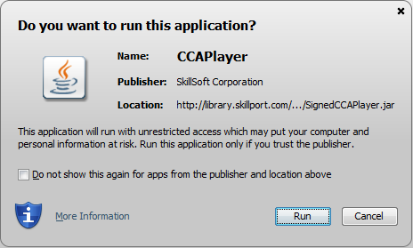 | This is the JRE prompt for the signed applet version of the Skillsoft Course Player for CCA courses. | The user must click Run to allow the applet to execute.  You can also check the box Do not show this again for apps from this Publisher and location above. This will suppress prompts for this applet on future launches, until the next JRE update.
When launching a CCA course using the signed Player applet and JRE v1.7.0_45:  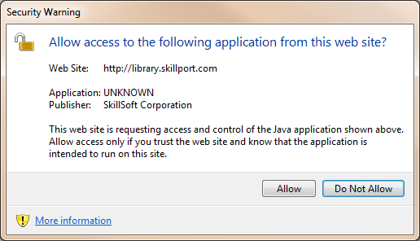 | After the usual JRE signed applet prompt, the user will see this secondary warning message.  Software engineering is working on a change to address the new requirements to eliminate the additional warning text and secondary message. | The user must click Run to allow the applet to execute.  The user must click Allow on the second warning message to allow the applet to run.  You can also check the box Do not show this again for apps from this Publisher and location above. This will suppress prompts for this applet on future launches.
When launching a CCA course:  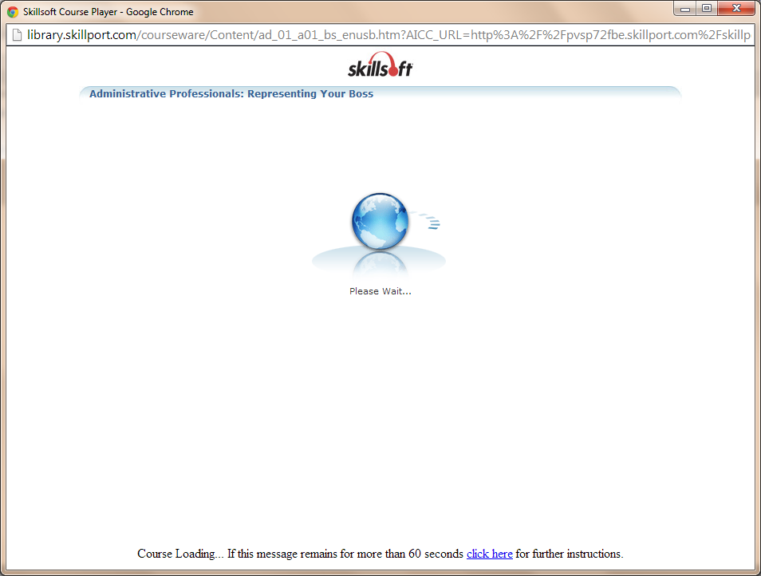 | After upgrading to JRE 1.7.0_45, when launching a course and after clicking Run on the initial signed or unsigned applet prompt, the course may fail to start and just remains on the Please Wait… page.  This is due to a change in the JRE which requires the option to “Keep temporary files on my computer” be enabled in the JRE. | In the Java Control Panel, General tab, under Temporary Internet Files, you must click Settings, and the option for Keep temporary files on my computer must be checked.
When trying to play a SCORM course or a CCA course deployed using SCORM:  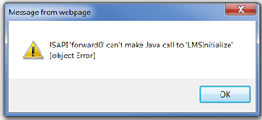  Or  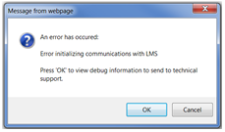 | This error will occur when using JRE 1.4.0_25, after the user was prompted to update to the current JRE, and they chose the option Later.  This is due to a security restriction in the JRE, which prevents certain operations if the JRE does not meet the minimum security baseline as dictated by Oracle. | The user must upgrade to the current JRE. Alternatively, you can reduce the security setting in the Java control panel to Medium, but Skillsoft does not recommend this option.
When launching a course from a third-party LMS using OLSA:  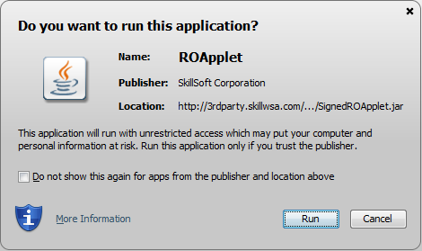 | This is the JRE signed applet prompt displayed when launching a course using OLSA and using the OLSA RO (Referral Object) applet. The ROApplet enables communication between the LMS and OLSA, when the LMS is not accessible from the Skillsoft content servers. | The user must click Run to allow the applet to execute.  You can also check the box Do not show this again for apps from this Publisher and location above. This will suppress prompts for this applet on future launches, until the next JRE update.
When exiting a CCA course:  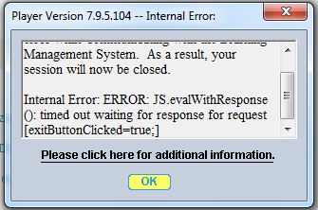 | This message may occur if using an older version of the JRE (below 1.7.0_45), after having chosen the option Later when prompted to upgrade the JRE. This is due to the JRE blocking LiveConnect functionality on older JREs when a new Security Baseline is established. LiveConnect is required for the Player to communicate with the LMS on exit. | The user must upgrade to the latest JRE (currently 1.7.0_45). Alternatively, you may reduce the Java security level to Medium, but Skillsoft does not recommend this option.
When launching an ElementK course: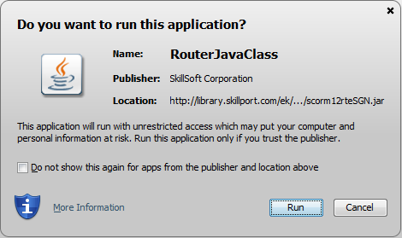 | This is the JRE prompt for the signed applet ElementK course player. | The user must click Run to allow the applet to execute.  You can also check the box Do not show this again for apps from this Publisher and location above. This will suppress prompts for this applet on future launches, until the next JRE update.
When launching a legacy Classic course:  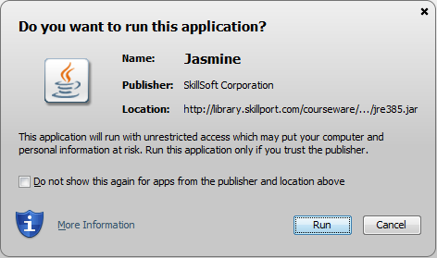 | This is the JRE prompt for the JRE signed applet for legacy Classic course player. | The user must click Run to allow the applet to execute.  You can also check the box Do not show this again for apps from this Publisher and location above. This will suppress prompts for this applet on future launches, until the next JRE update.
When launching a legacy e3 course:  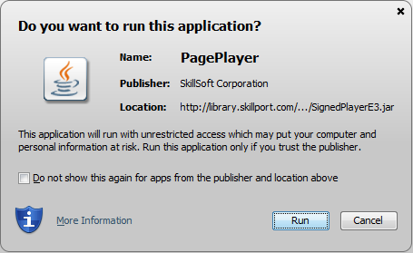 | This is the JRE prompt for the signed applet legacy e3 course player (notice SignedPlayerE3 in the Location). | The user must click Run to allow the applet to execute.  You can also check the box Do not show this again for apps from this Publisher and location above. This will suppress prompts for this applet on future launches, until the next JRE update.
When launching a legacy Business Skills course:  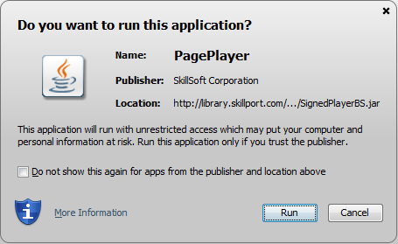 | This is the JRE prompt for the signed applet legacy Business Skills course player (notice SignedPlayerBS in the Location). | The user must click Run to allow the applet to execute.  You can also check the box Do not show this again for apps from this Publisher and location above. This will suppress prompts for this applet on future launches, until the next JRE update.
When launching a Skillsim:  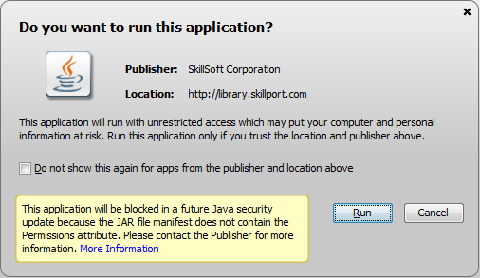  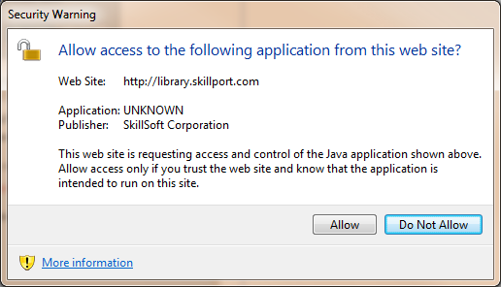  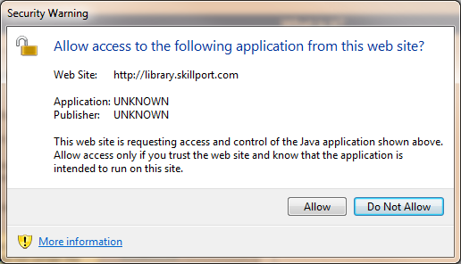 | This is the JRE prompt for a signed applet with JRE 1.7.0_45. New requirements around Java applet signing are causing the additional yellow warning text to appear for our signed applets.  These secondary warning messages are only displayed with some signed applets.  Software engineering is working on a change to address the new requirements to eliminate the additional warning text and secondary message. | The user must click Run to allow the applet to execute.  The user must click Allow on the second warning message to allow the applet to run.  You can also check the box Do not show this again for apps from this Publisher and location above. This will suppress prompts for this applet on future launches, until the next JRE update.
When launching a NETg course: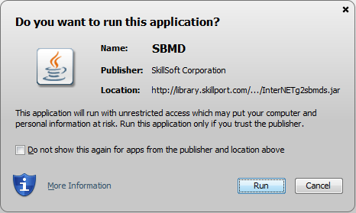  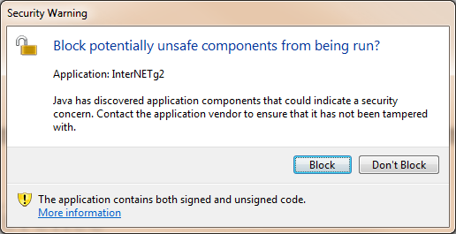 | This is the JRE prompt for the signed applet NETg NLS course player.  The initial signed applet prompt is followed by the JRE warning about blocking potentially unsafe components. This second message is due to the NETg player containing both signed and unsigned code. NETg courses are no longer supported, so there are no plans to update the player to address this additional warning. | The user must click Run to allow the applet to execute.  The user must click Don’t Block to allow the player to launch.
When using Publisher to upload a custom course:  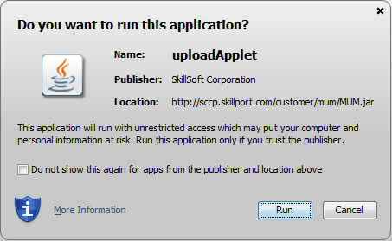 | This is the JRE prompt for the signed Publisher applet to upload custom content. | The user must click Run to allow the applet to execute.
When connecting to Dialogue Live (http://live.skilldialogue.com)  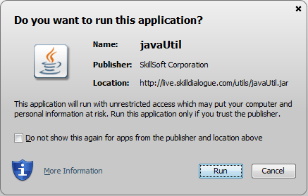 | This is the JRE prompt for the signed Dialogue Live applet. | The user must click Run to allow the applet to execute.
When editing a user profile or when editing a Learning Program or Series and specifying a custom image on Skillport 8:  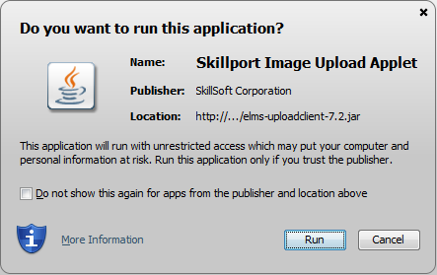 | This is the JRE prompt for the signed Image Upload applet in Skillport 8. This applet is used for uploading users’ profile images, as well as custom images for Learning Programs and Series folders. | The user must click Run to allow the applet to execute.
When Java tries to load an unsigned applet: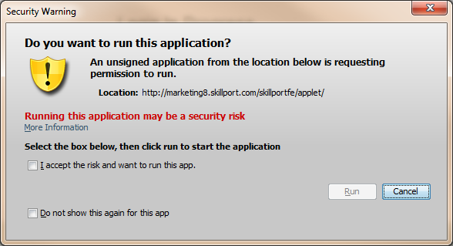 | This is the JRE prompt for an unsigned Java applet when using JRE version 1.7.0_25.  You should no longer see this message, since JRE 1.7.0_25 will no longer allow the use of unsigned applets, unless the security level has been set to Medium. | The user must check the box to accept the risk, and click Run. You can also check the box Do not show this prompt again for this app. If you see this prompt when launching a Skillsoft course, you may be able to switch to the signed version of the Player applet to replace this message with the signed applet warning.  NOTE: As of JRE v1.7.0_40, the checkbox to not show this again is no longer available.
After closing a passive asset that was launched from a LMS using OLSA:  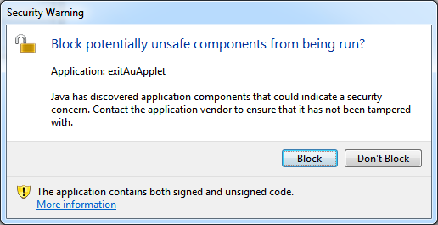 | This is a prompt for the OLSA ExitAuApplet, which is used to communicate passive asset completion status and duration back to a third-party LMS. The prompt is due to the applet containing both signed and unsigned code.  You should no longer see this message as the fix was deployed in the following Skillport patches:  Skillport 7.2 patch 26  Skillport 7.3 patch 17  Skillport 8.0 patch 5 | The user must click Don’t Block to allow the applet to communicate back to the LMS. If the user clicks Block, the asset status will not be updated in the third-party LMS.
When launching a Skillsim using the signed Player applet:  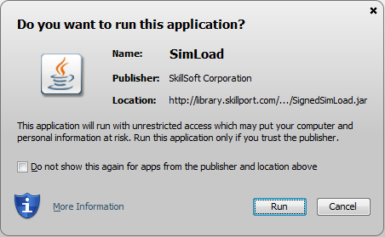  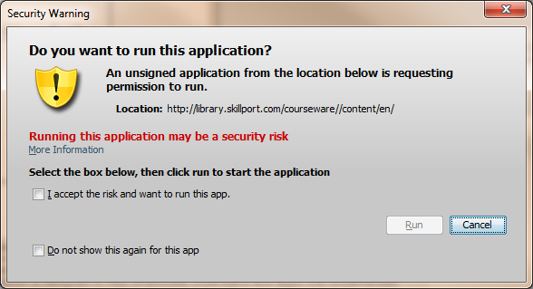 | This is the JRE prompt for the signed applet Skillsim player.  The initial signed applet prompt is followed by the unsigned applet prompt. This is due to the SkillSim player containing both signed and unsigned components.  This message should no longer appear as it was address in SimPLayer 2.4 SR18. | The user must click Run to allow the applet to execute.  The user must check the box to accept the risk, and click Run. You can also check the box to not show the prompt again for this applet.

